**INVEST**

Agile INVEST is an acronym that helps agile team assess the quality of user stories. The acronym "INVEST" is often used as a mnemonic to remember the characteristics of well-formed user stories in agile software development. Each letter in "INVEST" represents a key attribute of a user story:

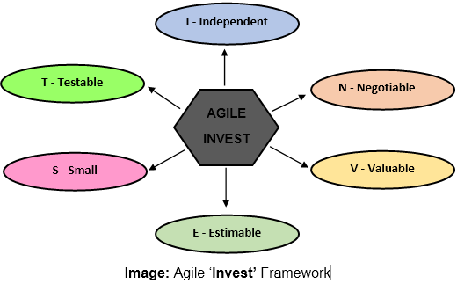

1. **I - Independent**: User stories should be independent of each other, allowing them to be developed and tested separately without dependencies on other stories.
2. **N - Negotiable**: User stories should be open to negotiation and discussion between the development team and stakeholders, allowing for changes and refinements as needed.
3. **V - Valuable**: User stories should deliver value to the end-users or customers. They should represent features or functionalities that contribute to achieving the project's goals and objectives.
4. **E - Estimable**: User stories should be estimable, meaning that the development team should be able to estimate the effort required to implement them accurately. This allows for better planning and resource allocation.
5. **S - Small**: User stories should be small enough to be completed within a single iteration or sprint. Breaking down features into small, manageable stories enables faster feedback loops and incremental delivery of value.
6. **T - Testable**: User stories should be testable, meaning that their acceptance criteria should be clear and measurable. This ensures that the development team and stakeholders have a shared understanding of what constitutes a successfully completed story.

**SCRUM**

Scrum is a popular framework used in Agile project management, particularly in software development, for managing and organizing complex tasks. It emphasizes iterative development, collaboration, and flexibility in responding to change. Here's a detailed explanation of Scrum:

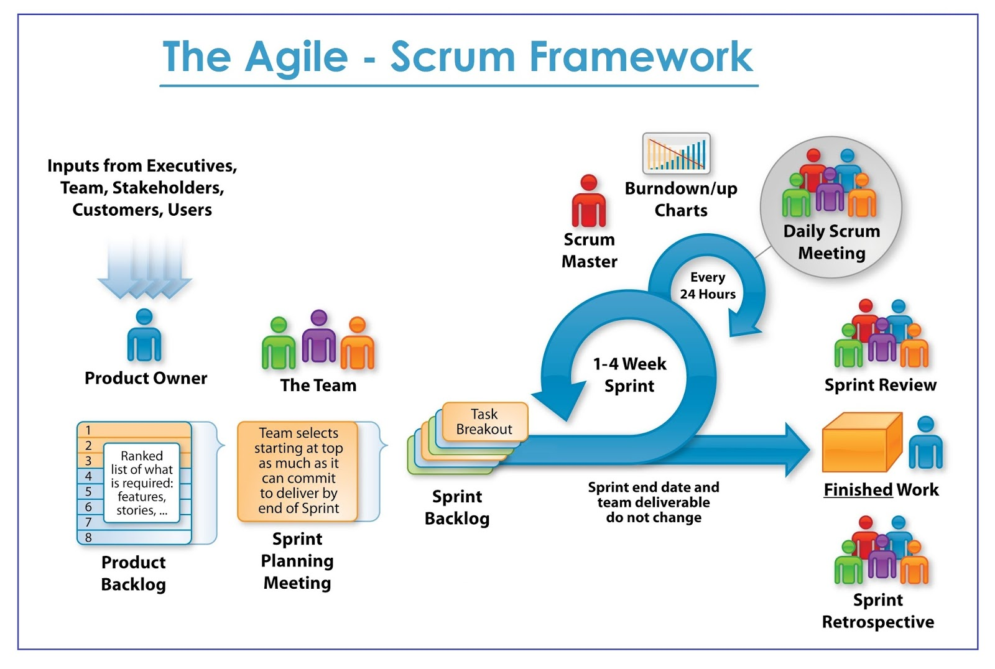

1. **Roles**:
   * **Product Owner**: Represents the stakeholders and is responsible for maximizing the value of the product.
   * **Scrum Master**: Facilitates the Scrum process, removes obstacles, and ensures the team adheres to Scrum principles.
   * **Development Team**: Cross-functional group responsible for delivering the product increment.
2. **Artifacts**:
   * **Product Backlog**: A prioritized list of all desired work on the project, maintained by the Product Owner.
   * **Sprint Backlog**: The subset of items from the Product Backlog selected for the Sprint, owned by the Development Team.
   * **Increment**: The sum of all completed Product Backlog items at the end of a Sprint, potentially shippable.
3. **Events**:
   * **Sprint**: A time-boxed period (usually 2-4 weeks) during which the Development Team works to deliver a potentially shippable product increment.
   * **Sprint Planning**: At the beginning of each Sprint, the Product Owner and the Development Team collaborate to select items from the Product Backlog to be worked on during the Sprint.
   * **Daily Scrum (Daily Standup)**: A 15-minute time-boxed event where the Development Team synchronizes activities and plans work for the next 24 hours.
   * **Sprint Review**: At the end of each Sprint, the Development Team demonstrates the increment to stakeholders and gathers feedback.
   * **Sprint Retrospective**: A meeting held after the Sprint Review to reflect on the Sprint and identify opportunities for improvement.
4. **Principles**:
   * **Empirical Process Control**: Scrum relies on the three pillars of transparency, inspection, and adaptation to manage complexity and unpredictability.
   * **Self-Organization**: Development Teams are empowered to organize and manage their own work to achieve Sprint goals.
   * **Collaboration**: Close collaboration between the Product Owner, Scrum Master, and Development Team is crucial for success.
   * **Iterative and Incremental**: Development occurs in small, incremental steps, with frequent inspection and adaptation.
5. **Advantages**:
   * **Flexibility**: Scrum allows for changes to be incorporated easily, even late in the development process.
   * **Transparency**: The framework provides visibility into the project's progress and impediments.
   * **Customer Satisfaction**: Regular feedback loops ensure that the product meets stakeholders' needs.
   * **Continuous Improvement**: Through Sprint Retrospectives, teams continuously improve their processes and performance.
6. **Implementation Considerations**:
   * **Team Size**: Typically, Scrum Teams consist of 5-9 members to maintain communication and collaboration.
   * **Dedicated Team**: Ideally, team members should be dedicated solely to the project during the Sprint.
   * **Co-location**: While not always possible, having team members in the same location facilitates communication and collaboration.

**SPRINTS**

Sprints are a short, time-boxed period for Scrum team that works to complete a set amount of work. Sprints are the core component of Scrum and agile methodology. The right sprints will help our agile team to ship better software.

What is sprint plan?

Sprint plan is an action in Scrum that kicks off the sprint. The primary purpose of sprint plan is to define what can deliver in the sprint. It also focuses on how the work will be achieved. It is done in combination with the whole Scrum team members.

The sprint is a set of the period where all the work to be done. Before we start the development, we have to set up the sprint. We need to describe how long time is required to achieve the sprint goal and where we are going to start.

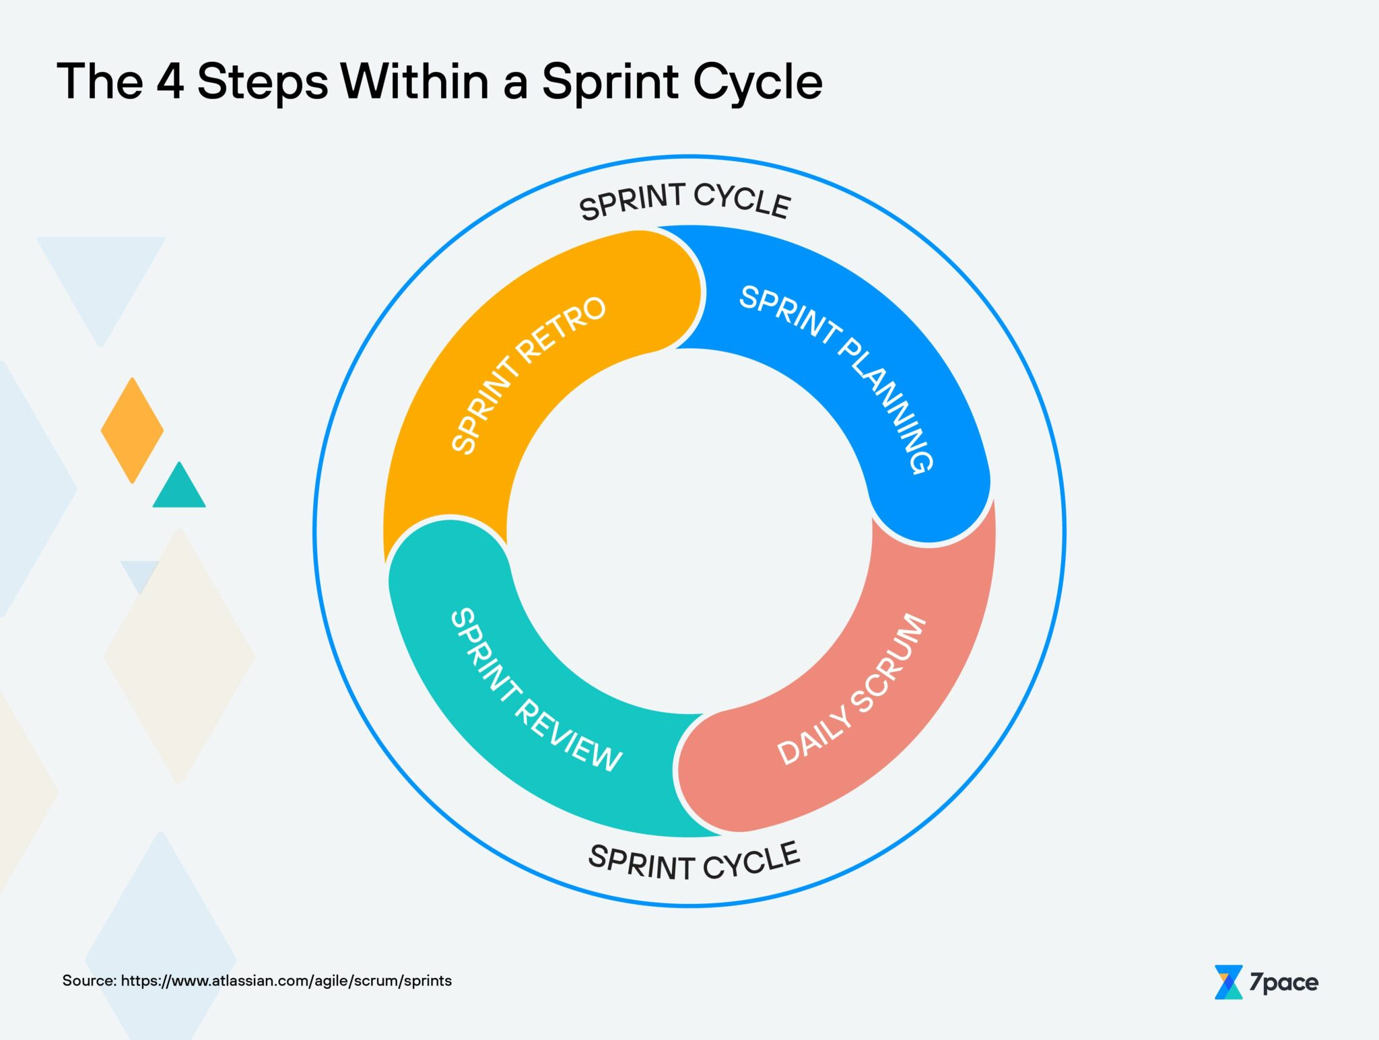

1. **Duration**: Sprints typically have a fixed duration, commonly ranging from two to four weeks. The duration is determined by the team based on factors such as the project's complexity, the nature of the work, and the organization's preferences.
2. **Goals**: Each Sprint has a clear goal or objective, defined collaboratively by the Product Owner and the Development Team. The goal guides the team's work and helps prioritize tasks from the Product Backlog.
3. **Product Backlog Items**: Before the start of a Sprint, the Product Owner selects a set of items from the Product Backlog to be worked on during the Sprint. These items are based on their priority and value to the product.
4. **Sprint Planning**: At the beginning of the Sprint, the entire Scrum Team (Product Owner, Scrum Master, and Development Team) participates in a Sprint Planning meeting. During this meeting:
   * The Product Owner presents the selected Product Backlog items.
   * The Development Team discusses how they will accomplish the work and creates a Sprint Backlog, which is a list of tasks needed to complete the selected items.
   * The team sets a Sprint Goal that articulates the purpose of the Sprint.
5. **Daily Scrum**: Throughout the Sprint, the Development Team holds a Daily Scrum meeting, also known as the Daily Standup. This meeting is time-boxed to 15 minutes and provides an opportunity for team members to synchronize their work, discuss progress, and identify any impediments.
6. **Development Work**: During the Sprint, the Development Team collaborates to complete the tasks defined in the Sprint Backlog. They work iteratively and incrementally, producing potentially shippable increments of the product at the end of each Sprint.
7. **Sprint Review**: At the end of the Sprint, the Development Team presents the completed work to stakeholders during the Sprint Review meeting. The purpose of this meeting is to gather feedback, discuss any changes to the Product Backlog, and ensure alignment with project goals.
8. **Sprint Retrospective**: Following the Sprint Review, the Scrum Team conducts a Sprint Retrospective meeting. During this meeting, team members reflect on the Sprint, identify what went well and what could be improved, and create actionable items for continuous improvement in future Sprints.
9. **Increment**: At the end of each Sprint, the Development Team delivers a potentially shippable product increment. This means the product has been enhanced with new functionality or improvements and is in a usable state.
10. **Repetition**: Once a Sprint is completed, the cycle begins again with the start of a new Sprint. Sprints continue iteratively until the project's goals are achieved or the project is terminated.